**SHREYAS G N**

**241059048**

**LINUX OS & SCRIPTING LAB**

**M.E – CYBER SECURITY**

1. **Create a file “poem.txt” with the following lines**

**We have not wings, we cannot soar;**

**But we have feet to scale and climb**

**By slow degrees, by more and more**

**The cloudy summits of our time.**

**The mighty pyramids of stone**

**That wedge-like cleave the desert airs**

**When nearer seen and better known**

**Are but gigantic flights of stairs.**

**The distant mountains that uprear**

**Their solid bastions of the skies**

**Are crossed by pathways that appear**

**As we to higher levels rise.**

**The heights by great men reached and kept**

**Were not attained by sudden flight**

**But they, while their companions slept**

**Were toiling upward in the night.**

**END**

**Henry Wadsworth Longfellow (1807–1882) was an American poet and educator.**

* gedit poem.txt

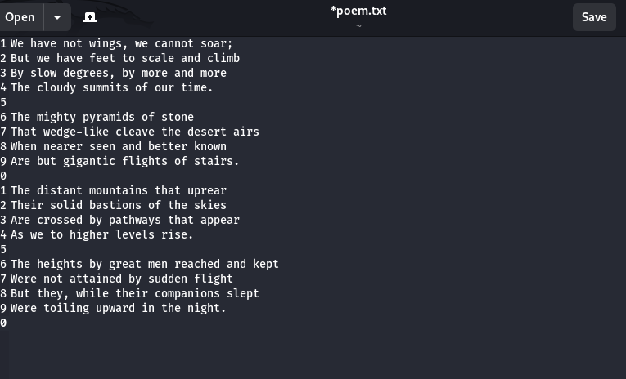

**Do the following task using grep command**

1. **Print all the lines other than pattern “they”**

* grep -v "they" poem.txt

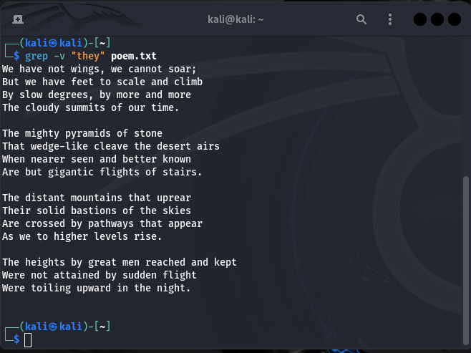

1. **Print all the lines with the pattern “they”**

* grep "they" poem.txt



1. **Print all the lines starts with “w”**

* grep "^w" poem.txt

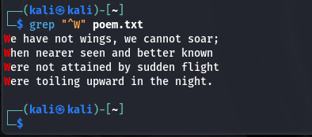

1. **Print the next lines after the pattern “stone” matches. Hint: man grep**

* grep -A 1 "stone" poem.txt



1. **Print the 2 lines above the pattern “stone” matches. Hint: man grep**

* grep -B 2 "stone" poem.txt



1. **Search the pattern with exact match**

* grep -x "pattern" poem.txt

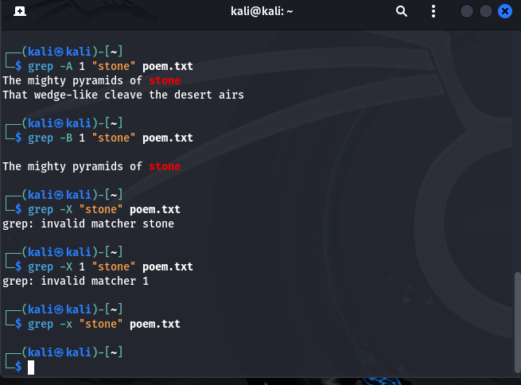

1. **Explore variations of grep command**
2. **ngrep -** Used for network packet filtering based on pattern matches.
3. **pgrep -** Searches for processes matching a pattern.
4. **zgrep -** Searches within compressed files.
5. **egrep -** Extended grep allowing additional regular expressions like +, |, etc.
6. **Write a shell script to get the pattern and filenames from the user and check whether the pattern is present or not.**

* #!/bin/bash

echo "Enter the pattern:"

read pattern

echo "Enter the filename:"

read filename

if grep "$pattern" "$filename"; then

echo "Pattern found"

else

echo "Pattern not found"

fi

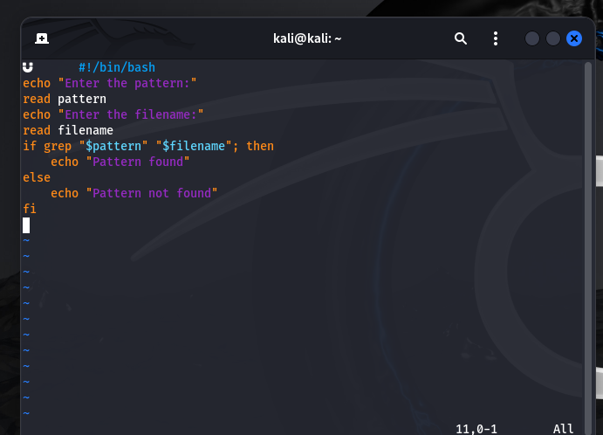

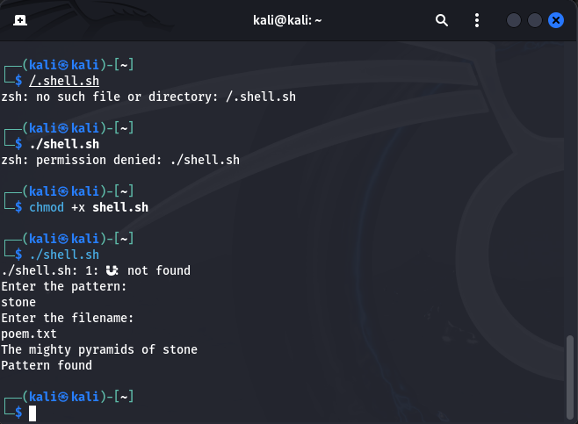

1. **Rewrite the above shell script using command line arguments. (Pass the pattern and file through command line arguments)**

* #!/bin/bash

pattern=$1

filename=$2

if grep "$pattern" "$filename"; then

echo "Pattern found"

else

echo "Pattern not found"

fi

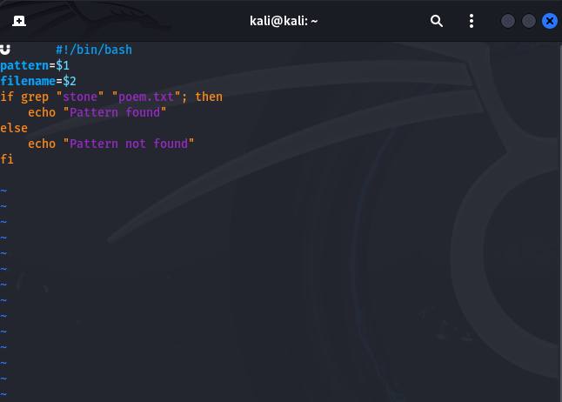

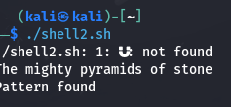

1. **Write a shell script to count total number of regular files in the current working directory.**

* #!/bin/bash

find . -type f | wc -l

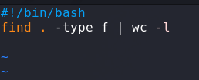

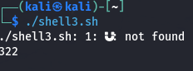

1. **Pipe**
2. **Pick the line from 3 to 5.**

* sed -n '3,5p' poem.txt

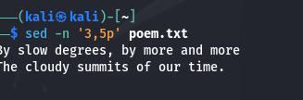

1. **List the top 5 largest files in a directory and display their sizes**

* ls -lS | head -5

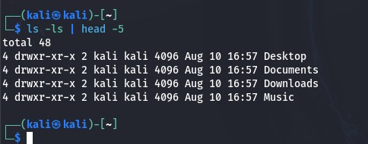

1. **Print the last 2 modified file details**

* ls -lt | head -3

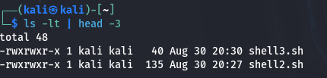

**7. Redirection**

1. **Convert uppercase into lowercase characters**

* tr '[:upper:]' '[:lower:]' < inputfile > outputfile

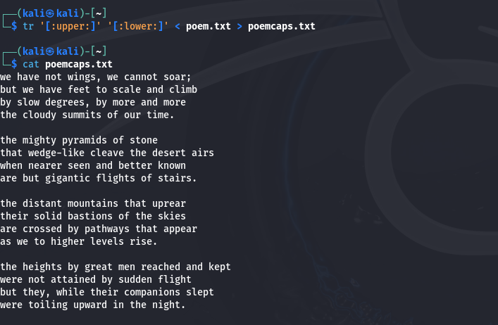

1. **Rewrite the shell script (3) using <<**

* #!/bin/bash

while IFS= read -r line; do

echo "$line"

done << EOF

$(grep "pattern" filename)

EOF

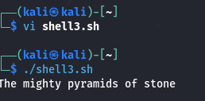 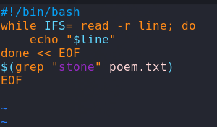

1. **List the contents of your current directory, including the ownership and permissions, and redirect the output to a file called contents.txt within your home directory.**

* ls -l > ~/contents.txt

